NUM PY PROGRAMS

1.Creat a numpy array with 10 integer elements and display its shape and data type.

AIM: To write a python program to create a NumPy array with 10 integer elements and display its shape and data type.

ALGORITHM:
1. Start.
2. Import the NumPy library.
3. Create a NumPy array containing 10 integer elements.
4. Display the array.
5. Find and display the shape of the array using shape.
6. Find and display the data type using dtype.
7. Stop.

CODE AND OUTPUT :
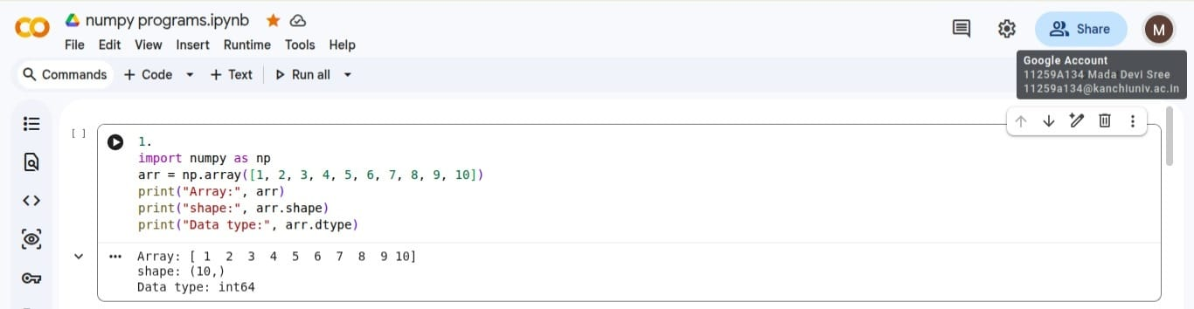
RESULT :
Thus, the Python program to create a NumPy array with 10 integer elements and display its shape and data type was executed successfully.

2.Creat a 4*4 Matrix filled with zeros , ones and an identity matrix.

AIM:To write a Python program to create a 4×4 matrix filled with zeros, ones, and an identity matrix using NumPy.

ALGORITHM:
1. Start.
2. Import the NumPy library.
3. Create a 4×4 matrix filled with zeros using zeros().
4. Display the zero matrix.
5. Create a 4×4 matrix filled with ones using ones().
6. Display the one matrix.
7. Create a 4×4 identity matrix using eye().
8. Display the identity matrix.
9. Stop.

CODE AND OUTPUT :

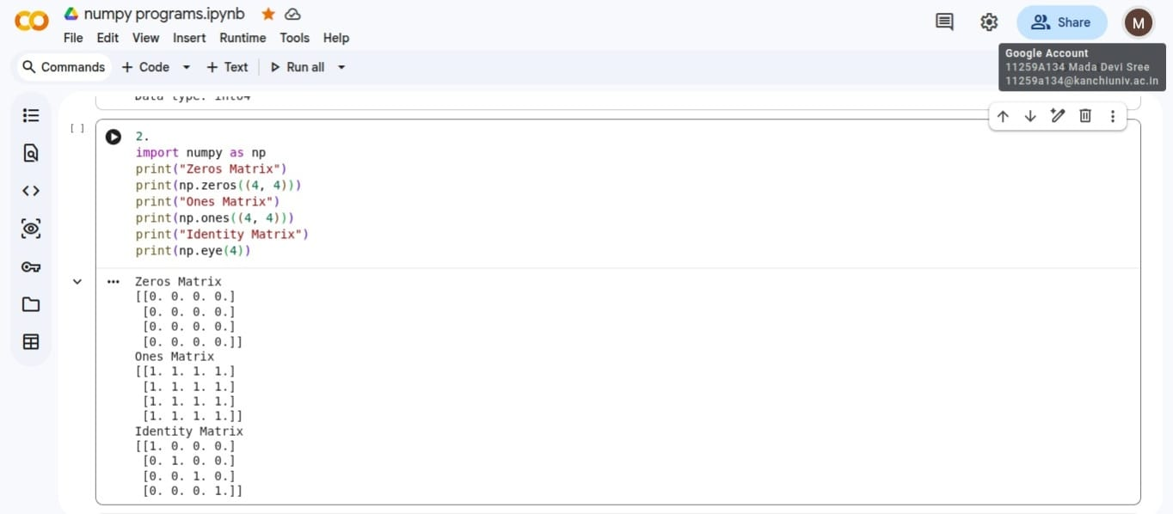

RESULT:
Thus, the Python program to create a 4×4 zero matrix, one matrix, and identity matrix using NumPy was executed successfully.

3. Generate numbers from 1 to 100 using arange() and reshape them into a 10×10 matrix.

AIM: To write a Python program to generate numbers from 1 to 100 using arange() and reshape them into a 10×10 matrix.

ALGORITHM:
1. Start.
2. Import the NumPy library.
3. Generate numbers from 1 to 100 using arange(1, 101).
4. Reshape the array into a 10×10 matrix using reshape().
5. Display the matrix.
6. Stop.

CODE AND OUTPUT :
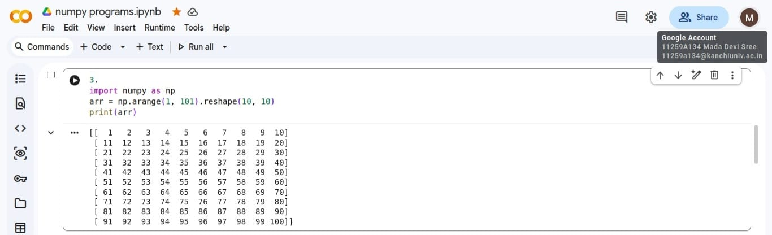

RESULT:
Thus, the Python program to generate numbers from 1 to 100 using arange() and reshape them into a 10×10 matrix was executed successfully.

4. Perform addition, subtraction, multiplication, and division on two NumPy arrays

AIM:To write a Python program to perform addition, subtraction, multiplication, and division on two NumPy arrays.
ALGORITHM:
- Start.
- Import the NumPy library.
- Create two NumPy arrays of equal size.
- Perform addition of the two arrays.
- Display the addition result.
- Perform subtraction of the two arrays.
- Display the subtraction result.
- Perform multiplication of the two arrays.
- Display the multiplication result.
- Perform division of the two arrays.
- Display the division result.
- Stop.
CODE AND OUTPUT :

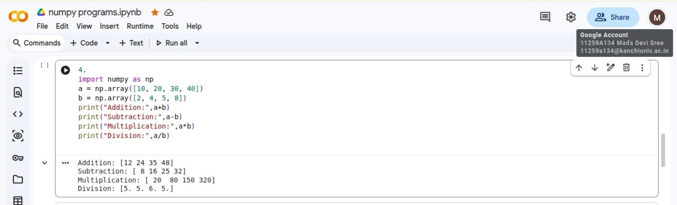
RESULT:
To write a Python program to perform addition, subtraction, multiplication, and division on two NumPy arrays.

5. Find the maximum, minimum, mean, median, and standard deviation of a NumPy array

AIM:To write a Python program to find the maximum, minimum, mean, median, and standard deviation of a NumPy array.
AlGORITHM:
- Start.
- Import the NumPy library.
- Create a NumPy array containing numerical elements.
- Find the maximum value using max().
- Find the minimum value using min().
- Calculate the mean using mean().
- Calculate the median using median().
- Calculate the standard deviation using std().
- Display all the calculated values.
- Stop.
CODE AND OUTPUT :
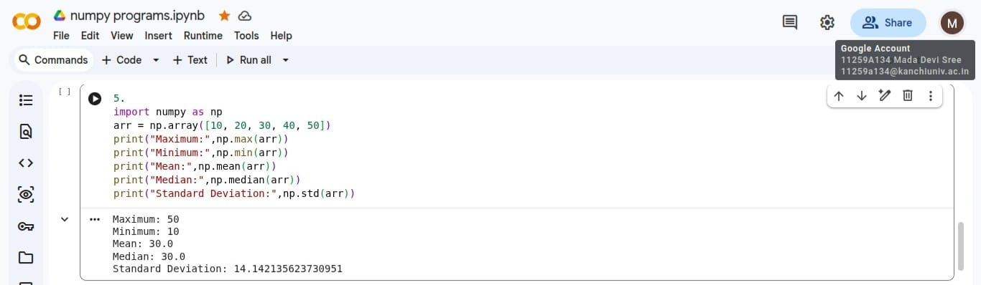

RESULT:
Thus, the Python program to calculate the maximum, minimum, mean, median, and standard deviation of a NumPy array was executed successfully.

6. Sort a NumPy array and identify the index of the largest and smallest elements

AIM:To write a Python program to sort a NumPy array and identify the indices of the largest and smallest elements.

ALGORITHM:
- Start.
- Import the NumPy library.
- Create a NumPy array.
- Sort the array using sort().
- Display the sorted array.
- Find the index of the smallest element using argmin().
- Find the index of the largest element using argmax().
- Display both indices.
- Stop.

CODE AND OUTPUT :
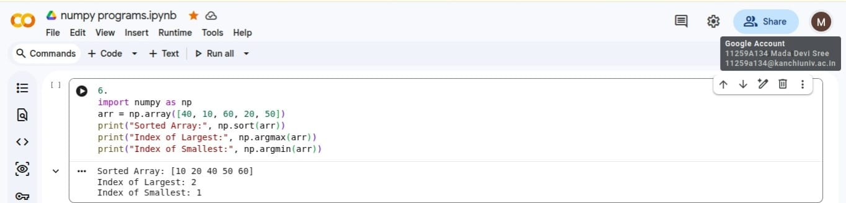

Result:
Thus, the Python program to sort a NumPy array and identify the indices of the largest and smallest elements was executed successfully.

7. Perform matrix multiplication and transpose operations on two matrices

AIM:To write a Python program to perform matrix multiplication and transpose operations on two matrices using NumPy.

ALGORITHM:
- Start.
- Import the NumPy library.
- Create two compatible matrices.
- Perform matrix multiplication using dot() or the @ operator.
- Display the multiplication result.
- Transpose the first matrix using .T.
- Display the transpose of the first matrix.
- Transpose the second matrix using .T.
- Display the transpose of the second matrix.
- Stop.
CODE AND OUTPUT :
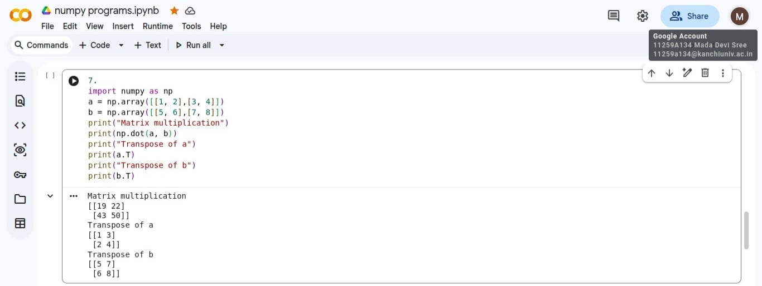
Result:
Thus, the Python program to perform matrix multiplication and transpose operations on two matrices was executed successfully.

8. Extract all even numbers from a NumPy array using Boolean indexing

AIM:To write a Python program to extract all even numbers from a NumPy array using Boolean indexing.

ALGORITHM:
- Start.
- Import the NumPy library.
- Create a NumPy array containing integers.
- Check which elements are divisible by 2 using the condition array
%2 == 0.
- Store the even elements using Boolean indexing.
- Display the even numbers.
- Stop.

CODE AND OUTPUT :
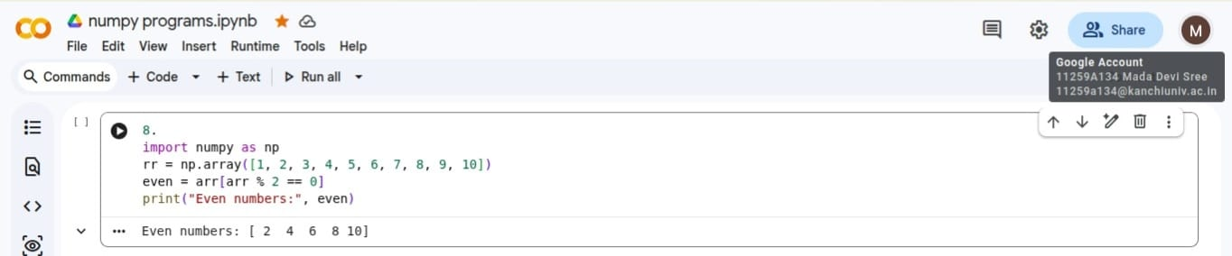

Result:
Thus, the Python program to extract all even numbers from a NumPy array using Boolean indexing was executed successfully.

9. Generate 20 random integers between 1 and 100 and count how many are greater than 50

AIM:To write a Python program to generate 20 random integers between 1 and 100 and count the numbers greater than 50.

ALGORITHM:
- Start.
- Import the NumPy library.
- Generate 20 random integers between 1 and 100 using random.randint().
- Display the generated integers.
- Check each element to determine whether it is greater than 50.
- Count the elements greater than 50 using sum().
- Display the count.
- Stop.

CODE AND OUTPUT :
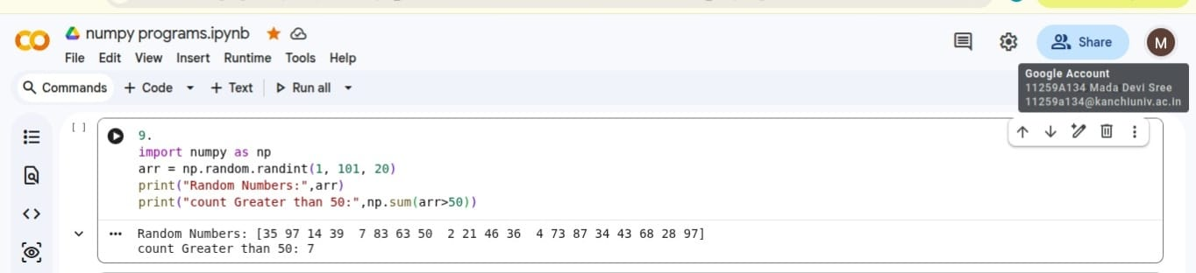

Result:
Thus, the Python program to generate 20 random integers between 1 and 100 and count the numbers greater than 50 was executed successfully.

10. Create a 5×5 random matrix and calculate the sum of each row and each column

AIM:To write a Python program to create a 5×5 random matrix and calculate the sum of each row and each column.
ALGORITHM:
- Start.
- Import the NumPy library.
- Generate a 5×5 random matrix.
- Display the matrix.
- Calculate the sum of each row using sum(axis=1).
- Display the row sums.
- Calculate the sum of each column using sum(axis=0).
- Display the column sums.
- Stop.
CODE AND OUTPUT :
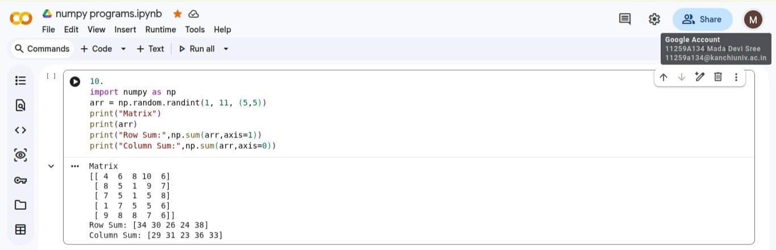

Result:
Thus, the Python program to create a 5×5 random matrix and calculate the sum of each row and each column was executed successfully.

